**Lab 2 Report: 3D models**

Title: 3D models

Notice: Dr. Bryan Runck

Author: Diego Osorio

Date: 11/2/2022

**Project Repository:** https://github.com/osori050/GIS5571/tree/main/Lab2

**Google Drive Link:**

**Time Spent:** 28

**Abstract**

This lab aims to create ETL pipelines for multidimensional datasets. First, elevation models are obtained from .las files downloaded from the Minnesota Geospatial Commons and an exploratory analysis is carried out in 2D and 3D. Also, a dataset corresponding to 30-year normal annual precipitation from PRISM is used to create time space cubes and a time series animation. The digital models and the space time cubes are successfully created with highly accurate results. Nonetheless, the multidimensional raster obtained prior to the cubes displays precipitation values out of the footprint (extent).

**Problem Statement**

The purpose of this lab is to analyze datasets containing information about elevation and precipitation over 30 years and convert them into 3D models. First, an ETL is needed to download a .las file from the Minnesota Department of Natural Resources (MNDNR), transform the dataset to a digital elevation model (DEM) and a triangular irregular network (TIN), and export layouts in PDF of said DEM and TIN. Also, a side-by-side exploratory data analysis is carried out to compare the visualization of a .las file in 2D and 3D on ArcPro. Finally, a pipeline is built to obtain .bil files for precipitation from PRISM Climate Group, convert the datasets into spacetime cubes, and create an animation of the time series. Figure 1 illustrates roughly the ETL-pipeline conceptual model.

Figure 1. ETL pipelines

Table 1. Data required

|  |  |  |  |  |  |  |
| --- | --- | --- | --- | --- | --- | --- |
| **#** | **Requirement** | **Defined As** | **(Spatial) Data** | **Attribute Data** | **Dataset** | **Preparation** |
| 1 | Point cloud | Raw input .las file from MNDNR | 3D data | Elevation | Mn GeoSpatial Commons | Convert .las file to LAS Dataset, then convert the LAS Dataset to raster function and TIN. |
| 2 | Precipitation over 30 years | 30-year normal .bil files from PRISM | Raster | Precipitation and time | PRISM | Add the .bil files to mosaic dataset, build multidimensional info, make multidimensional raster, and create space time cubes |

**Input Data**

First, the point cloud obtained consists of 13,921,928 points, its projected coordinate system is North American HARN UTM Zone 15 N, and its vertical coordinate system is NAVD88 - Geoid03 (Meters). The extension goes from 4,941,636,37 to 4,975,133.56 m latitude and 430,569.07 to 433,083.79 m longitude.

Regarding the precipitation dataset, it has the 30-year normal precipitation over the 48 contiguous states from 1991 to 2020. The package contains 12 monthly precipitation and 1 annual precipitation .bil files. The coordinate system is NAD 1983.

Table 2. Input data

|  |  |  |  |
| --- | --- | --- | --- |
| **#** | **Title** | **Purpose in Analysis** | **Link to Source** |
| 1 | 4342-12-05.las | Creation of elevation models | https://resources.gisdata.mn.gov/pub/data/elevation/lidar/examples/lidar_sample/las/ |
| 2 | 30-yr Normal Precipitation: Annual | Space-time analysis of precipitation in the U.S. | https://prism.oregonstate.edu/normals/ |

**Methods**

To begin with, the .las dataset was downloaded from the Minnesota Geospatial Commons API. Then a LAS dataset was created on ArcPro. This was later used to create the TIN and DEM files which were saved as layer files as well for visualization purposes. Parallelly, a block of code was created to reference the analysis to the current project and the map, and the layer files were added to the map. Also, a layout was referenced to the project to integrate the layers and then export them as PDFs as shown in Figure 2.

Figure 2. Workflow of the elevation models

Additionally, the LAS data set was uploaded to Map and Global Scene to analyze and compare the visualizations in 2D and 3D respectively. The side-by-side exploratory analysis was done by linking views using the Center and Scale options under the View tab.

The .bil files were obtained through a post request from PRISM API. To integrate all the monthly precipitation rasters, creating a raster mosaic was needed first which was saved to the default geodatabase of the project. Once created the mosaic, the .bils were added to it except for the annual .bil. Then two fields were added to the attribute table through the Calculate Field tool: i) a column with the name Variable whose value was “Precipitation”, ii) another column with the name Timestamp whose value was generated using arcade language to populate the corresponding month of each raster plus a random day and year within the time window of the dataset. These two fields were utilized to build the multidimensional information of the mosaic and make a multidimensional raster layer. With the latter, a Space Time Cube layer was created from which a visualization in 3D was generated as well.

As the visualization was taking too long to load (after two hours it had only loaded the cubes over Texas) a query was used to select the cubes with OBJECTID less than or equal to 100,000 in Properties. Also, in the Time tab in Properties, the “Each feature has a single time field” was assigned to Layer Time, “End Date” to Time Field, and “1/1/2017 06:00:00 AM – 12/1/2017 06:00:00 AM” to Time Extent. Then, in the Time tab on top of ArcPro, the Span and Step interval were fixed to 1 month. The Animation Properties under the Animation Tab was modified to an Append Time equal to 00:00.500 and the latter was imported as Time Slider Steps to create the animation. Finally, the Export Movie tool was used to create the time series animation gif. Figure 3 exhibits the workflow of the time space cubes.

Figure 3. Workflow of time space cubes

**Results**

Figure 4 illustrates the DEM and TIN models created with the LAS dataset.

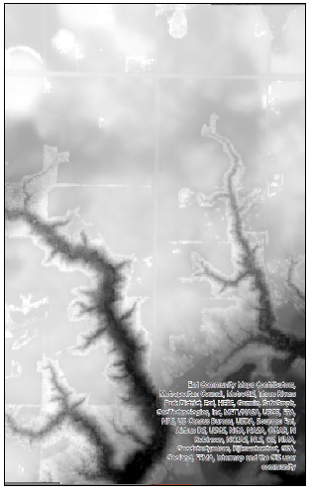.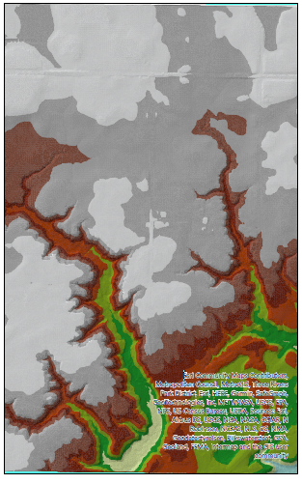

Figure 4. DEM (left) and TIN (right) models after being exported as PDFs.

Figure 5 shows the exploratory analysis in 2D and 3D of the LAS dataset. ArcPro allows for zooming in and out, rotating, and tilting (only 3D) the dataset. Likewise, the symbology pane has the option to visualize the data as points, contour lines, edges, or surfaces.

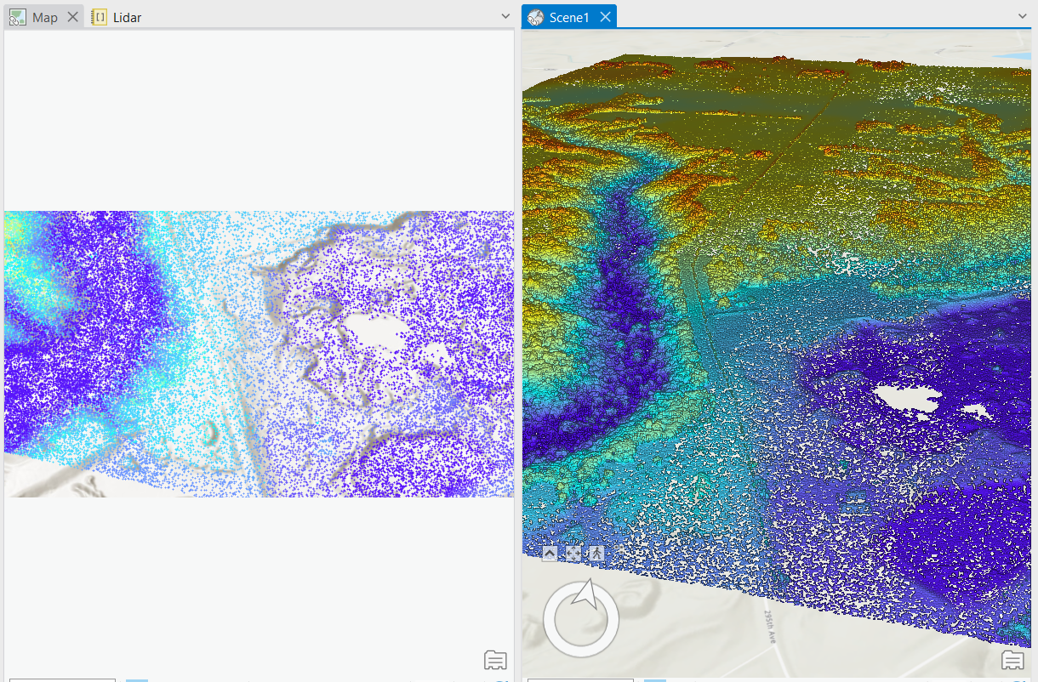

Figure 5. Visualization in 2D (left) and 3D (right) of the LAS dataset.

There is also a LAS Dataset Layer tab (Figure 6) where other functions can be found such as swipe to see what underneath is without toggling the dataset off, transparency to visualize what is underneath too, LAS Points to select the types of return points to be displayed, among others.

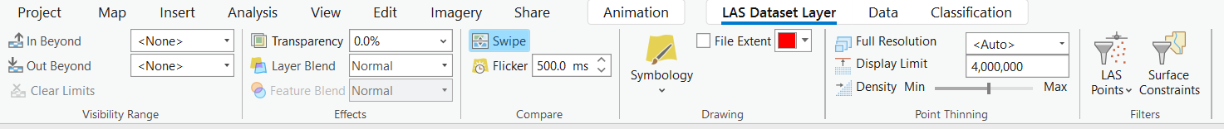

Figure 6. LAS Dataset Layer tab.

Regarding the multidimensional raster, Figure 7 shows a previsualization of it.

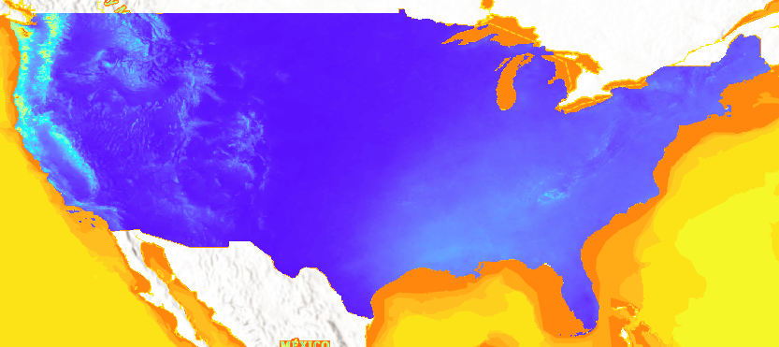 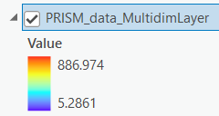

Figure 7. Multidimensional raster

Finally, Figure 8 corresponds to the frames used to create the time series animation gif.

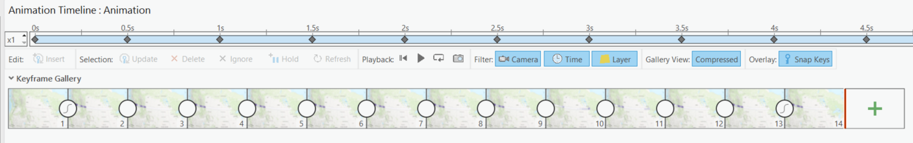

Figure 8. Time series animation

**Results Verification**

The results obtained in the elevation models are accurate and correspond with the expected outcomes. That is, low values are displayed in the valleys and canyons in comparison to those of the mountains. Likewise, there is consistency as the results between the two datasets (DEM and TIN) and the visualization in 2D and 3D of the LAS dataset yielded the same expected results.

However, the values for the multidimensional raster are a bit strange. As seen in Figure 9, the footprint of the mosaic dataset encompasses only the 48 contiguous states, but when the multidimensional layer was created, it showed values for the 48 contiguous states plus the oceans. Indeed, the oceans were displayed with the highest values as shown above in Figure 7 (yellow to red color) and I did not know why. Despite this, the results within the 48 contiguous states are consistent with the values of the .bil files.

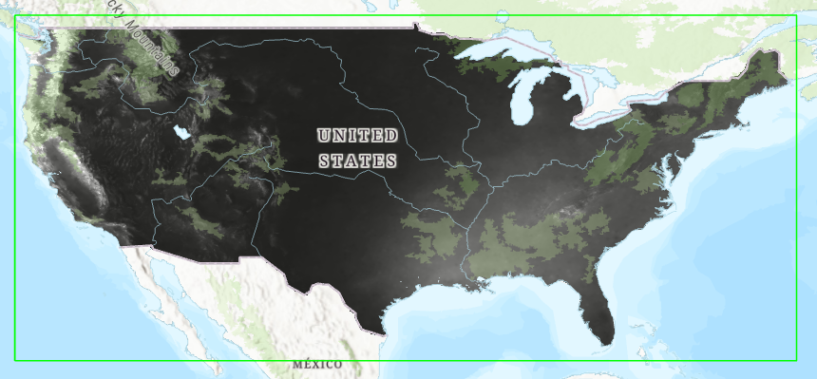

Figure 9. Mosaic dataset with footprint

**Discussion and Conclusion**

Built on Lab1, this lab explores new formats and analyses of datasets obtained from web APIs. On the one hand, the creation of the elevation models was relatively simple, and the results obtained were highly accurate. On the other hand, the multidimensional analysis got me stuck for hours since it was not straightforward to understand and follow. First, I spent more than 5 hours trying to figure out how to download the data from PRISM without a link. I tried to create a block of code able to open the web browser and right-click the button to use the “Save as” function as shown in Figure 10, although it happened not to be the right approach.

Figure 10. Attempt to download PRISM data by right clicking the ‘Download All Normals Data (.bil)’ button.

Second, adding the rasters to the new mosaic dataset worked well at first, but then, when I reran the code (without changing anything), I got errors as the mosaic was populated with strange values (Figure 11) regardless of using python or the tool. After multiple attempts, the mosaic finally was populated with reasonable values by creating first a variable with the coordinate system and then adding it to the arcpy.management.CreateMosaicDataset() function.

Figure 11. Strange values populated when adding rasters to mosaic dataset.

Third, when the Space Time Cubes were created, their visualization in either 2D or 3D took hours. Moreover, the way the lab instructions are written hints the animation must be made with code which also got me several hours looking for the geoprocessing tool(s) to create it. In the end, I had to do it the animation manually as I did not find a way to integrate it into the ETL pipeline.

The positive aspect of this lab was getting to know multidimensional datasets as the topic was new to me. However, the lab instructions are unnecessarily shallow and ambiguous making too much time wasted in searching for information and writing the wrong code (a rabbit hole).

**References**

MNDNR. (2012). *Index of /pub/data/elevation/lidar/examples/lidar_sample/las*. Retrieved from Minnesota Geospatial Commons: https://resources.gisdata.mn.gov/pub/data/elevation/lidar/examples/lidar_sample/las/

Oregon State University. (2021). *30-Year Normals*. Retrieved from PRISM: https://prism.oregonstate.edu/normals/

**Self-score**

|  |  |  |  |
| --- | --- | --- | --- |
| **Category** | **Description** | **Points Possible** | **Score** |
| **Structural Elements** | All elements of a lab report are included **(2 points each)**:  Title, Notice: Dr. Bryan Runck, Author, Project Repository, Date, Abstract, Problem Statement, Input Data w/ tables, Methods w/ Data, Flow Diagrams, Results, Results Verification, Discussion and Conclusion, References in common format, Self-score | 28 | 28 |
| **Clarity of Content** | Each element above is executed at a professional level so that someone can understand the goal, data, methods, results, and their validity and implications in a 5 minute reading at a cursory-level, and in a 30 minute meeting at a deep level **(12 points)**. There is a clear connection from data to results to discussion and conclusion **(12 points)**. | 24 | 24 |
| **Reproducibility** | Results are completely reproducible by someone with basic GIS training. There is no ambiguity in data flow or rationale for data operations. Every step is documented and justified. | 28 | 28 |
| **Verification** | Results are correct in that they have been verified in comparison to some standard. The standard is clearly stated **(10 points)**, the method of comparison is clearly stated **(5 points)**, and the result of verification is clearly stated **(5 points)**. | 20 | 20 |
|  |  | 100 | 100 |